**ASSIGNMENT 6**

Name: Imon Raj

Class: BCSE III

Roll: 002010501098

Section: A3

Subject: Computer Networks Lab Report

**PROBLEM STATEMENT: Use Cisco Packet Tracer software to do the following experiments.**

**Overview :** This entire assignment has been done using the CISCO Packet tracer tool.

**System** : Linux (Ubuntu 20.04)

Connect two hosts back-to-back with a crossover cable. Assign IP addresses, andsee whether they are able to ping each other.

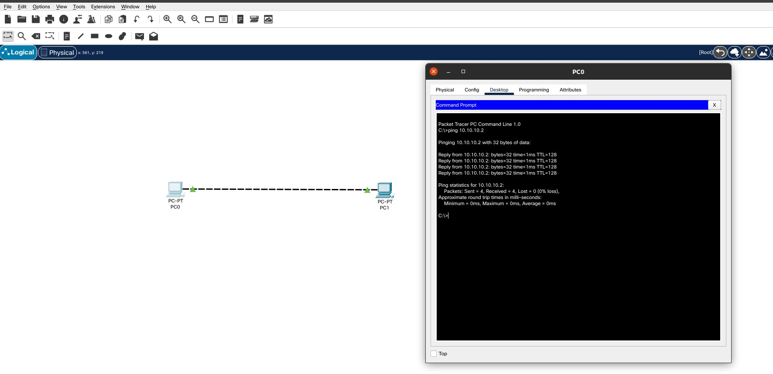

1. Create a LAN (named LAN-A) with 3 hosts using a hub. Ping each pair of nodes.

host with ip 10.10.10.1 pinging to 10.10.10.2

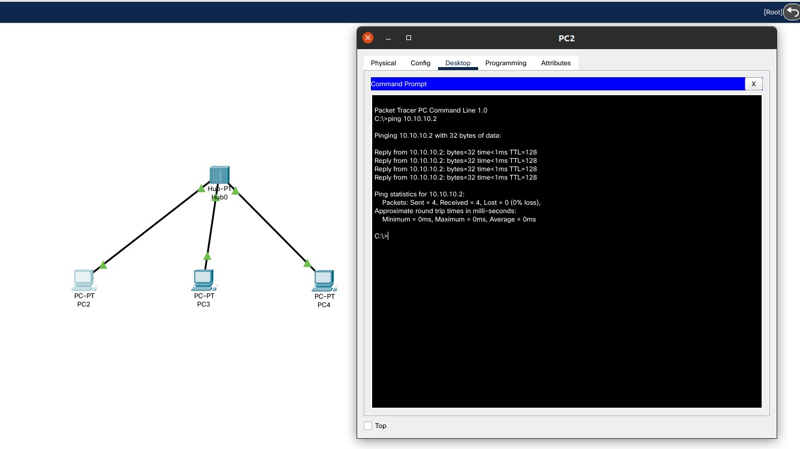

host with ip 10.10.10.2 pinging to 10.10.10.3

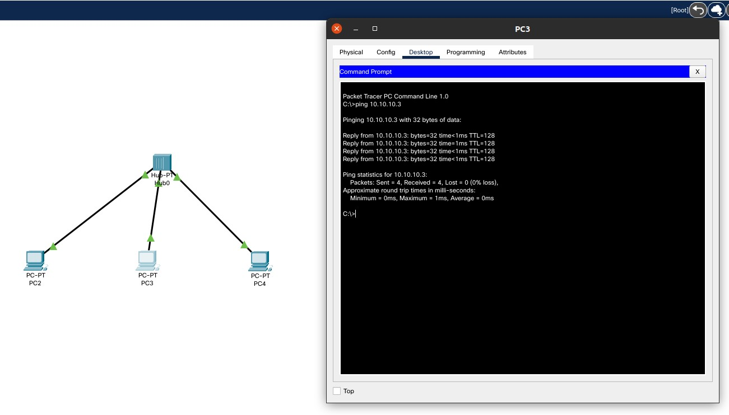

host with ip 10.10.10.3 pinging to 10.10.10.1

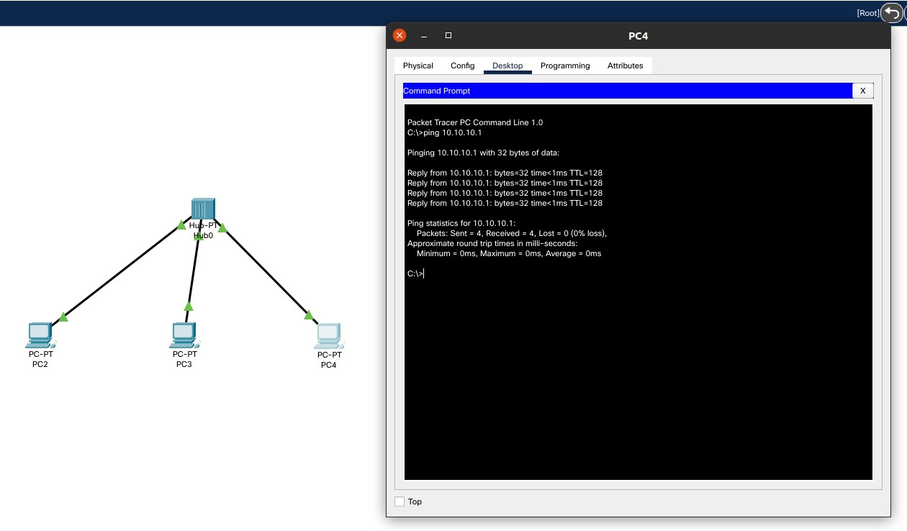

1. Create a LAN (named LAN-B) with 3 hosts using a switch. Record contents of theARP Table of end hosts and the MAC Forwarding Table of the switch. Ping each pair of nodes. Now record the contents of the ARP Table of end hosts and the MAC Forwarding Table of the switch again.

Initial contents of the MAC Address table for the switch

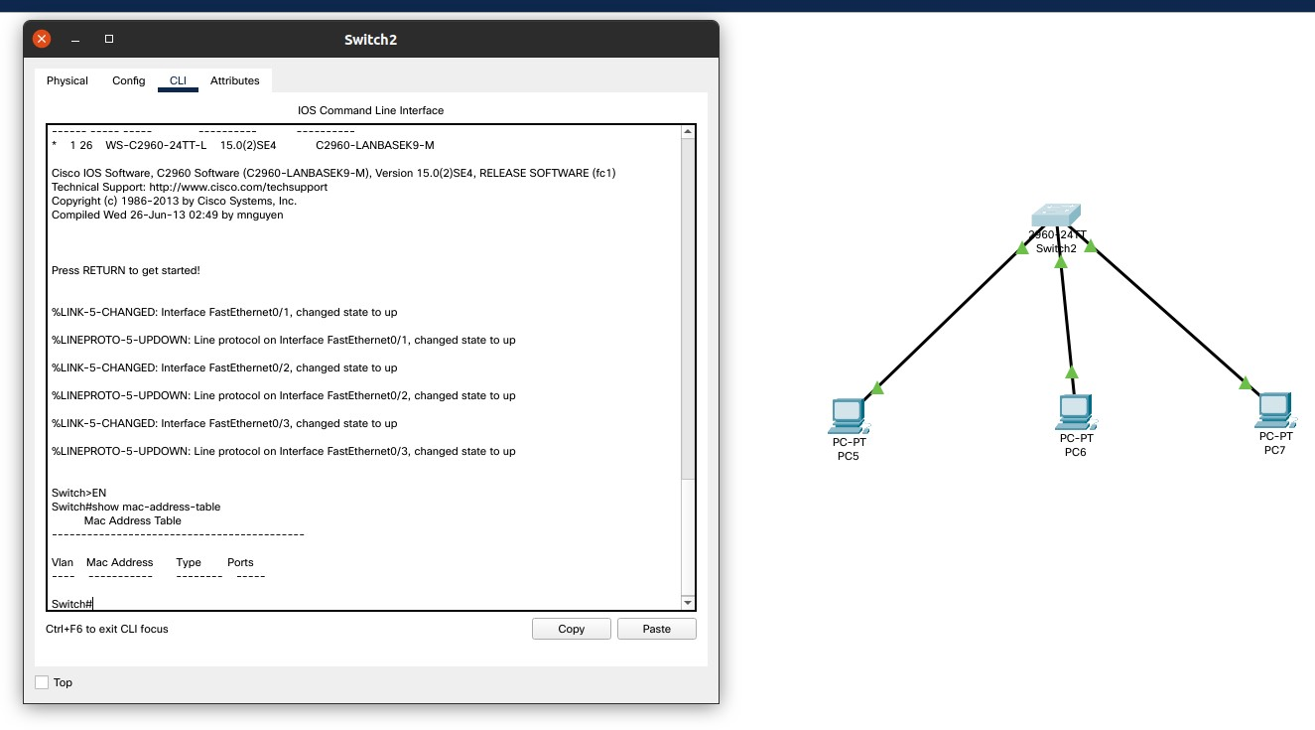

ARP Record of host 1 before sending

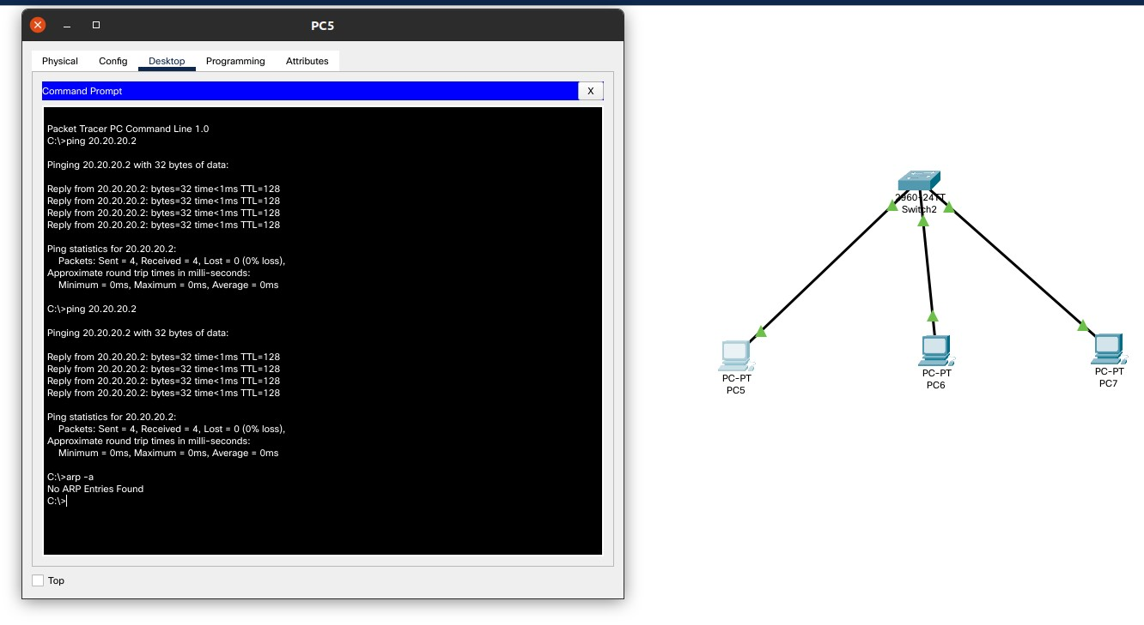

ARP Record of host 1 after pinging host 2

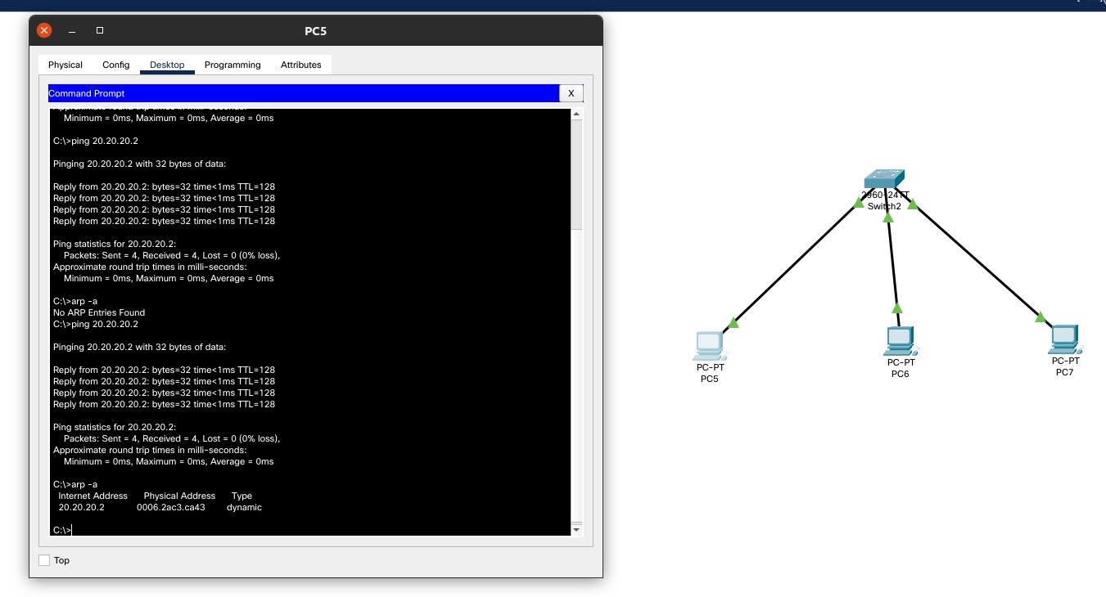

MAC Address Table of the switch after a ping operation from host1 -> host2

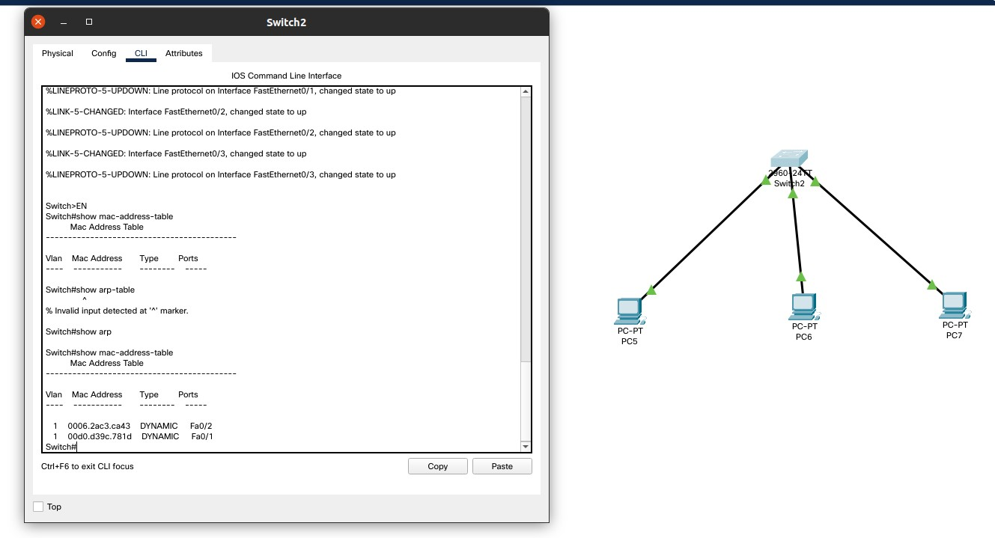

1. Connect LAN-A and LAN-B by connecting the hub and switch using a crossovercable. Ping between each pair of hosts of LAN-A and LAN-B. Now record the contents of the ARP Table of end hosts and the MAC Forwarding Table of the switch again.

ARP Table after connecting LAN A and LAN B

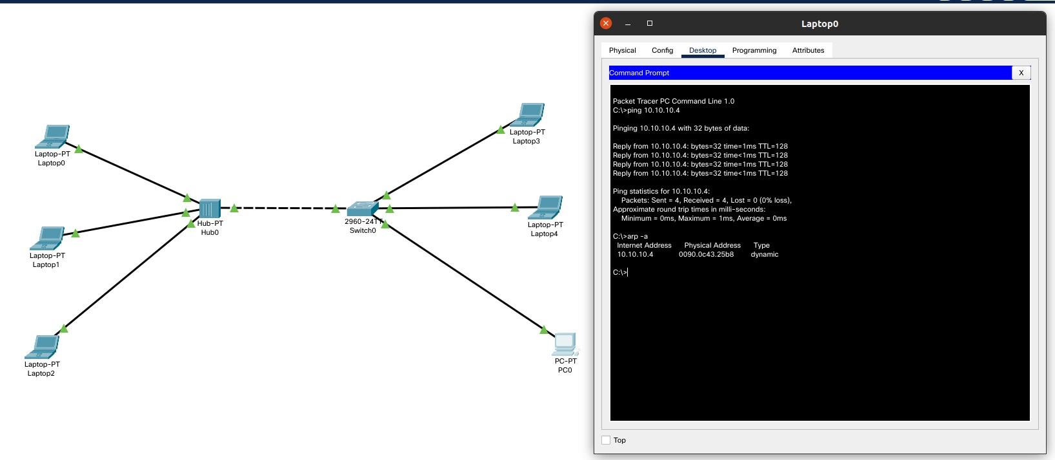

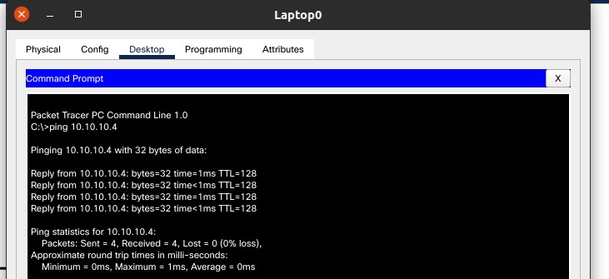

MAC Forwarding Table of the switch in LAN B

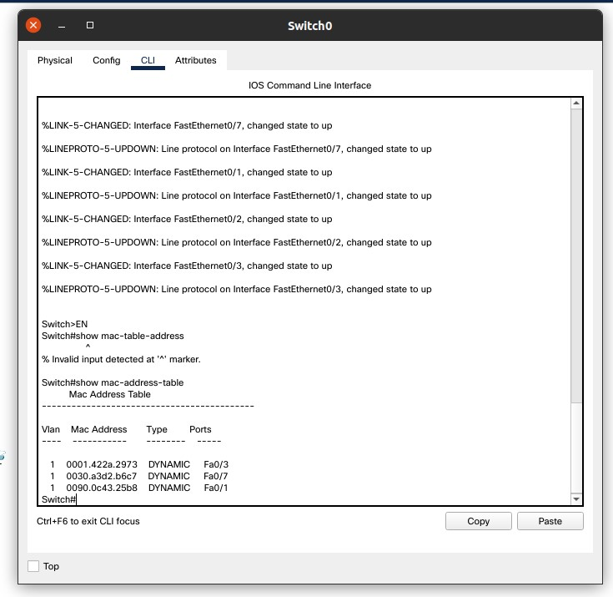

1. Create a LAN (named JU-Main) with three hosts connected via a layer-2 switch(Cisco 2950 switch PC-LAB1-Switch). Connect the switch to a router (Cisco 1818). Assign IP addresses to all the hosts and the router interface connected to this LAN from network 192.168.148.0/24. Configure the default gateway of each host as the IP address of the interface of the router which is connected to the LAN. Create another

LAN (named JU-SL) with three hosts connected via a layer-2 switch (Cisco 2950 switch PC-LAB2-Switch). Connect this switch to another router (Cisco 1818). Assign IP addresses to all the hosts and the router interface connected to this LAN from network 192.168.149.0/24. Configure the default gateway of each host as the IP address of the interface of the router which is connected to the LAN. Connect the two routers through appropriate WAN interfaces. Assign IP addresses to the WAN interfaces from network 192.168.150.0/24. Add static route in both of the routers to route packets between two LANs.

Network Layout

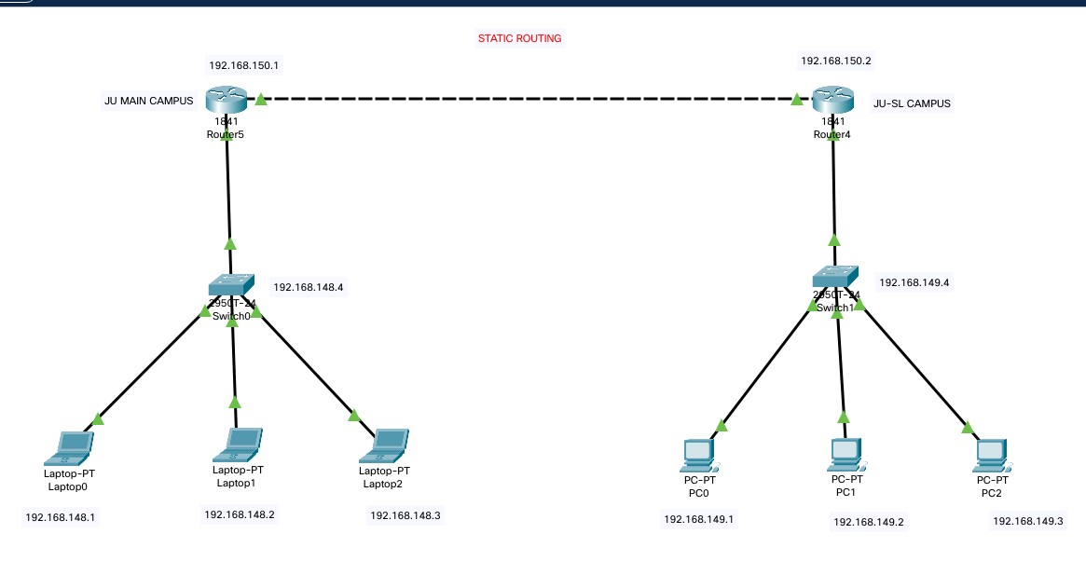

Pinging a host (192.168.149.2, JU-SL Campus) from a host (192.168.148.2, JU-MAIN Campus) using static routing.

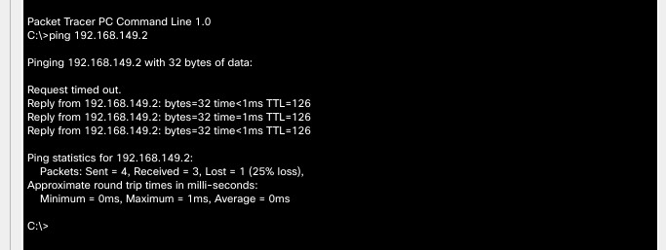

1. Add servers to the individual LANs (in problem 5) and configure them as a DHCPserver. Configure the hosts in the individual LAN to obtain IP addresses and address of the default gateway via this DHCP server.

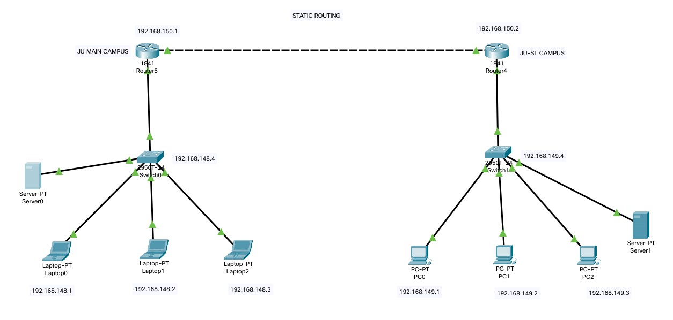

1. Create a LAN (CSE) with three hosts connected via a layer-2 switch (Cisco 2950 switch CSE-Switch). Also add a web server and a ftp server to this LAN. The hosts dynamically get their IP addresses from a local DHCP server. Servers are assigned fixed IP addresses. Configure the individual hosts to use the local DNS server for name resolution. Add a Domain Name Server (DNS) to this LAN. Create appropriate records in the DNS server for the individual servers in the LAN. The domain name of the LAN is cse.myuniv.edu. Configure the individual hosts to use the local DNS server for name resolution.

Network Layout

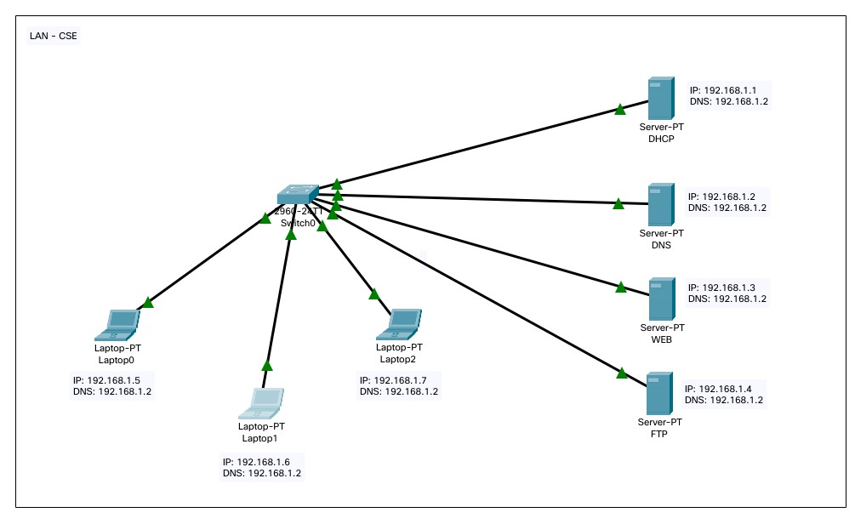

# IP Configuration of a Laptop

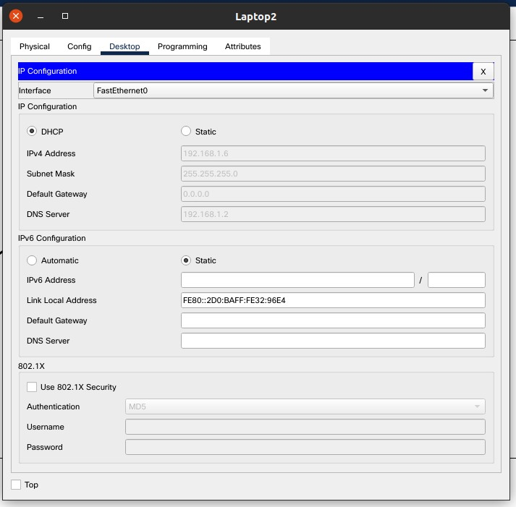

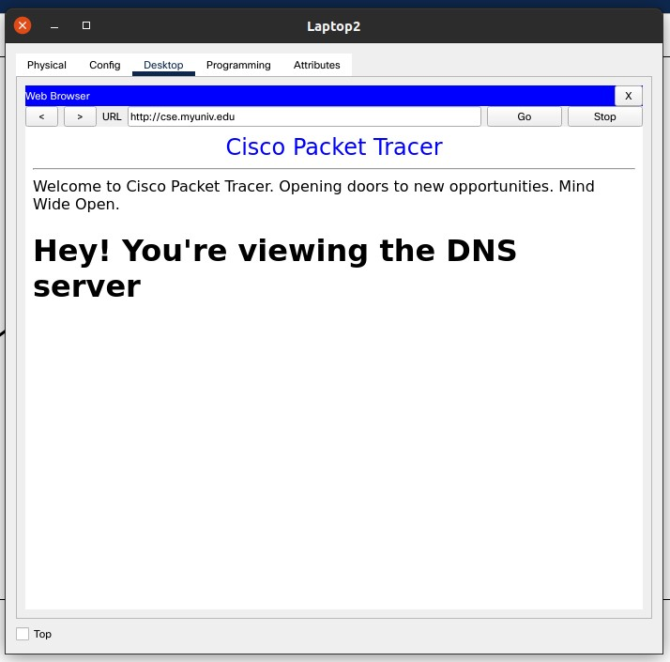

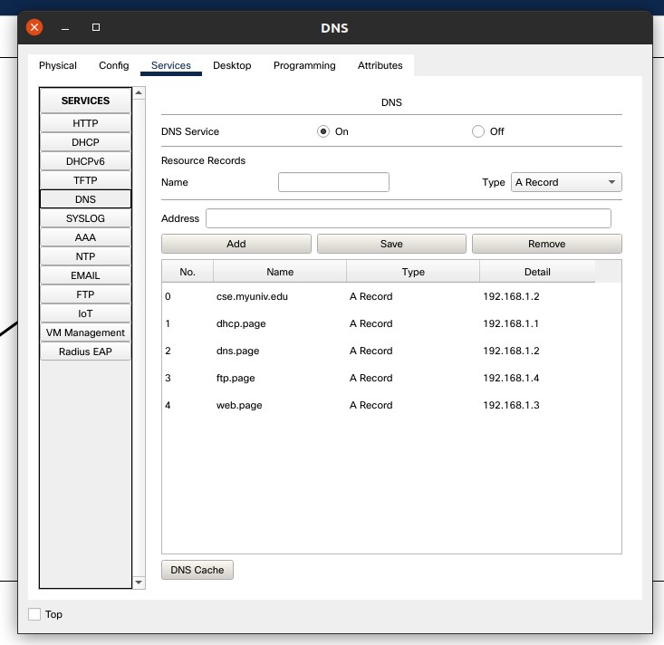

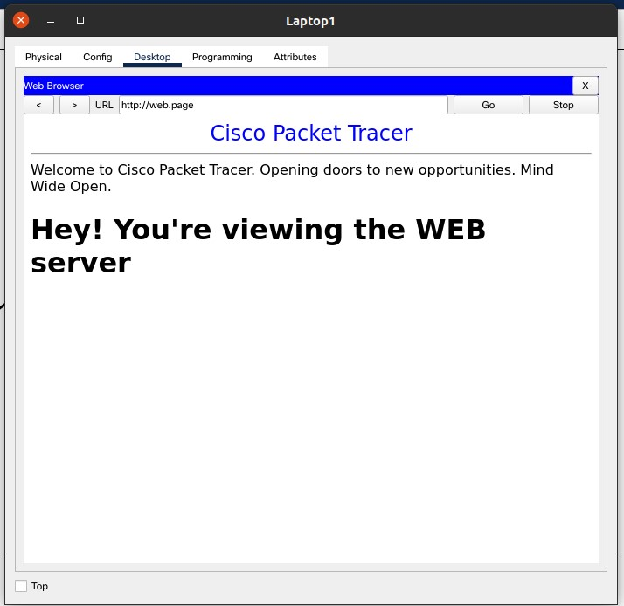

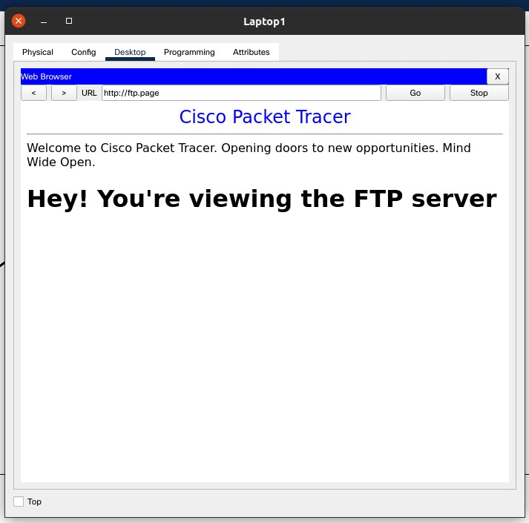

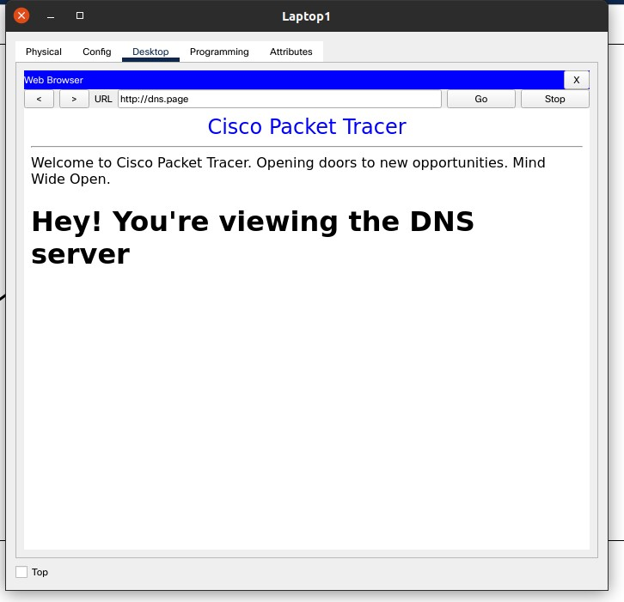

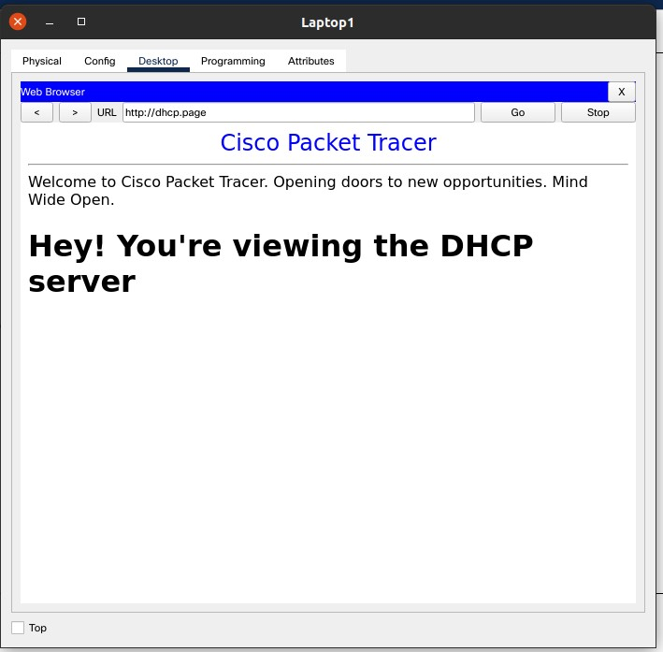

**Comments :**

The CISCO packet tracer is actually a pretty useful tool in simulating the Network Layout. It can help to plan the architecture, simulate events and then deploy it in real life so that we can be aware about the performance of the network in production. Further it helps experience a practical knowledge of how elements of an entire work are when deployed in an integrated fashion. Hoping to get more of such assignments to that learning becomes fun and not stressful.